4

HANA 1809 Assessment Report

©

KTern

-

Limited to Kaar Technologies and Emirate Steel Industries



UI/UX

Design

–

VP/

IT Dashboard

KTern

Suite 607, 4100, Spring Valley Road,

Dallas TX75244

[https://ktern.co](https://ktern.com/)

[m](https://ktern.com/)

©

All rights reserved

1. Initial Screen (Default Template)
   1. Program Start Date
   2. Program End Date
   3. Wave 1 Start Date
   4. Wave 1 End Date
   5. Program Progress, Weightage
   6. Wave 1 Progress, Weightage
   7. Wave 2 Progress, Weightage
   8. Current Phase
   9. Program Momentum
   10. Phase Cards

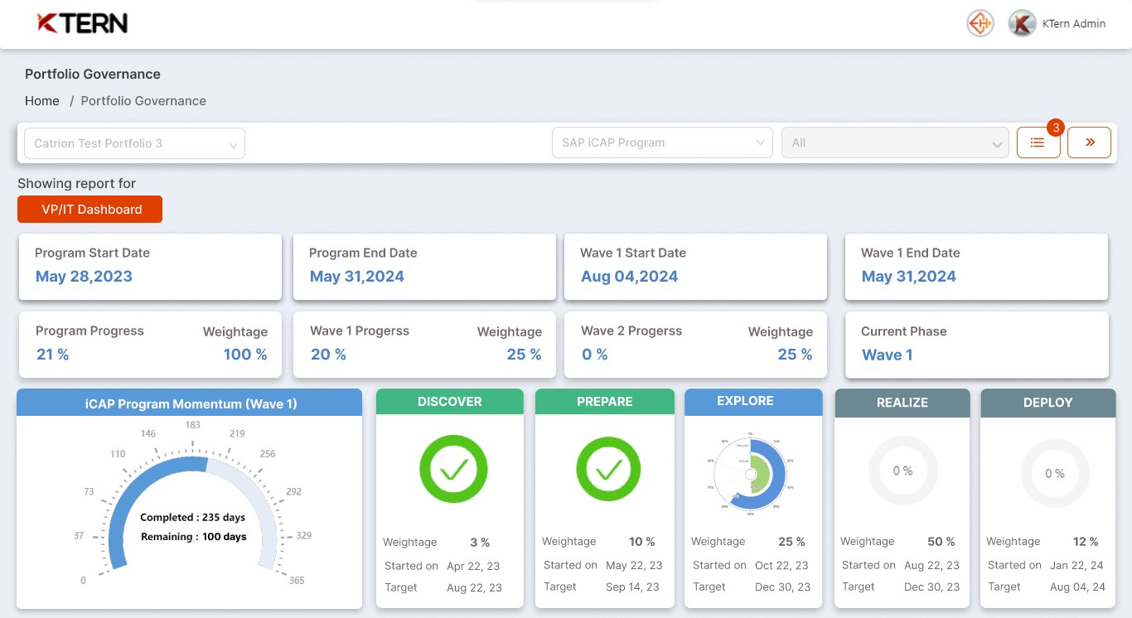

1. Timeline View and Roadmap
   1. Monthly Timeline
   2. Weekly Timeline
   3. Roadmap for next stages

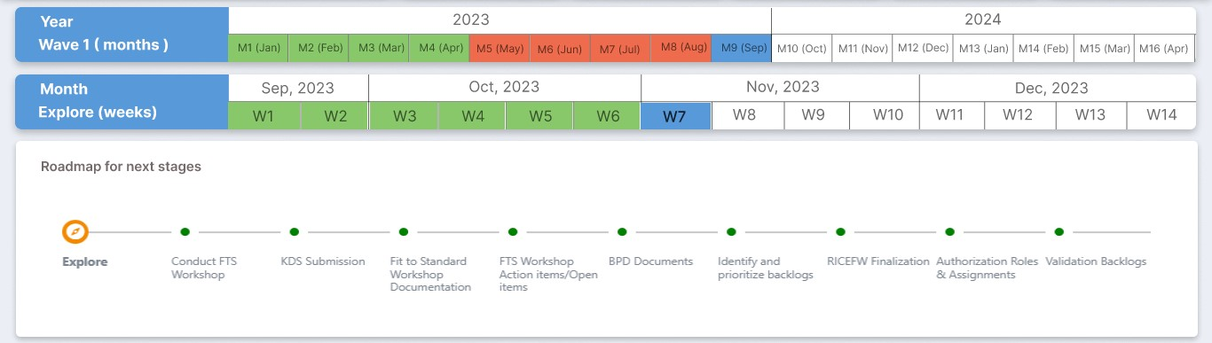

1. Segment Statistics
   1. Global Scope items (GSI) Coverage
   2. Overall Session Coverage

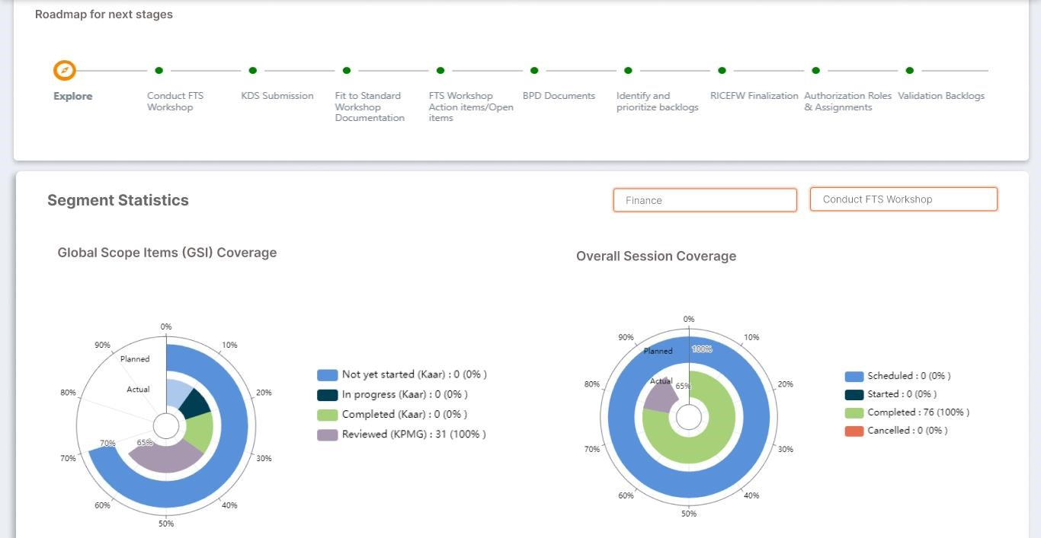

1. Configurable Reports Table with CTA Tracker and Versioning
   1. Daily DSR Activities
   2. Data Migration Activities
   3. Deliverables
   4. Risks & Mitigations

